**IFT 466 Advanced Computer Networks**

**Lab 31  
WAN – Building a DSL network**

After you complete each step, put a ‘√’ or ‘x’ in the completed box

**Objectives**

To build a DSL Network

1. We will start this lab by creating our topology. Add the cloud (from the WAN emulation tab), then click on the cloud and then go to the config tab.

Under connections, click DSL where we will add Modem 4 and Modem 5, where we are mapping them to Ethernet (Ethernet 6) where our ISP will be connected.

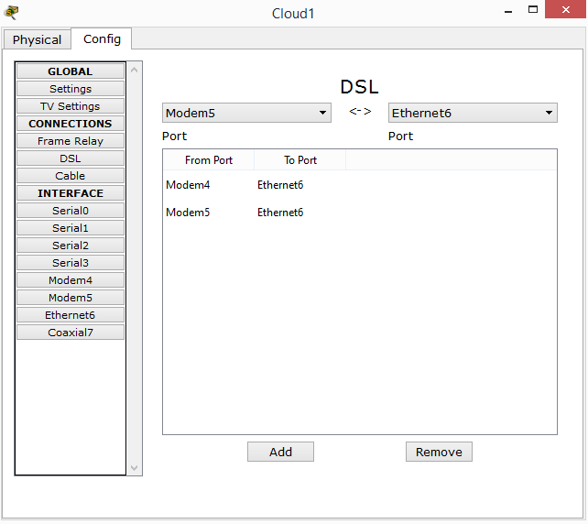

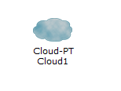



✓

While still in the Cloud window, click on Ethernet6 and it should be set for DSL (if not, make it so).

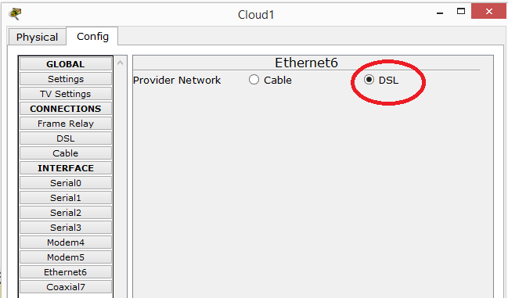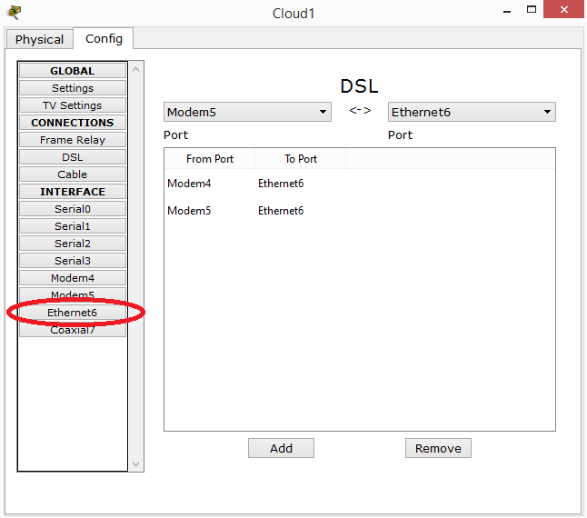



✓

1. For the ISP side, we will use the 2811 router. Connect the ISP router to the cloud (FA0/0 to Ethernet6) via a straight through cable

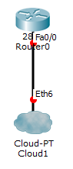



✓

1. Now we will add a server (Web server) which will simulate the Internet e.g. DNS etc.

****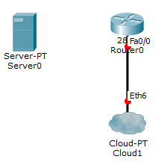

✓

1. Now will start the configuration on the ISP router

Add a switch port module to the router which will be our connection to the server

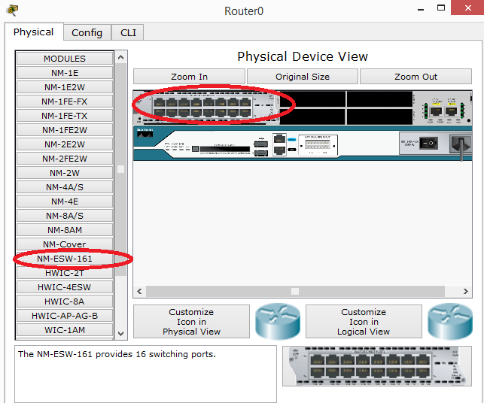



✓

1. We will first configure the Fa0/0 that is connected to the cloud. We will also disable CDP so not to broadcast that stuff out from our ISP and finally rename our router to ISP.



****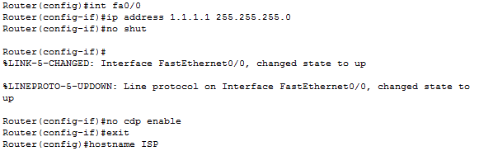

✓

1. We now configure our switchport module that’s connected to our server. We will create a VLAN for the devices that will be connected to the switch (we added this switch to our router in step 4).   
     
   After we create the VLAN, we will configure the switchport module.

We will run the show command “do show ip int brief” where we have Fa0/1 to Fa1/15 is our switchport module.

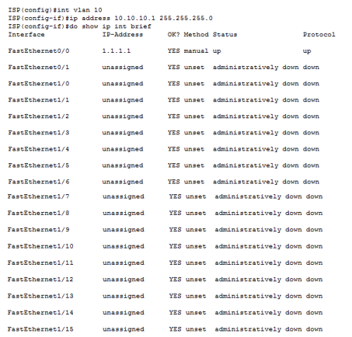



✓

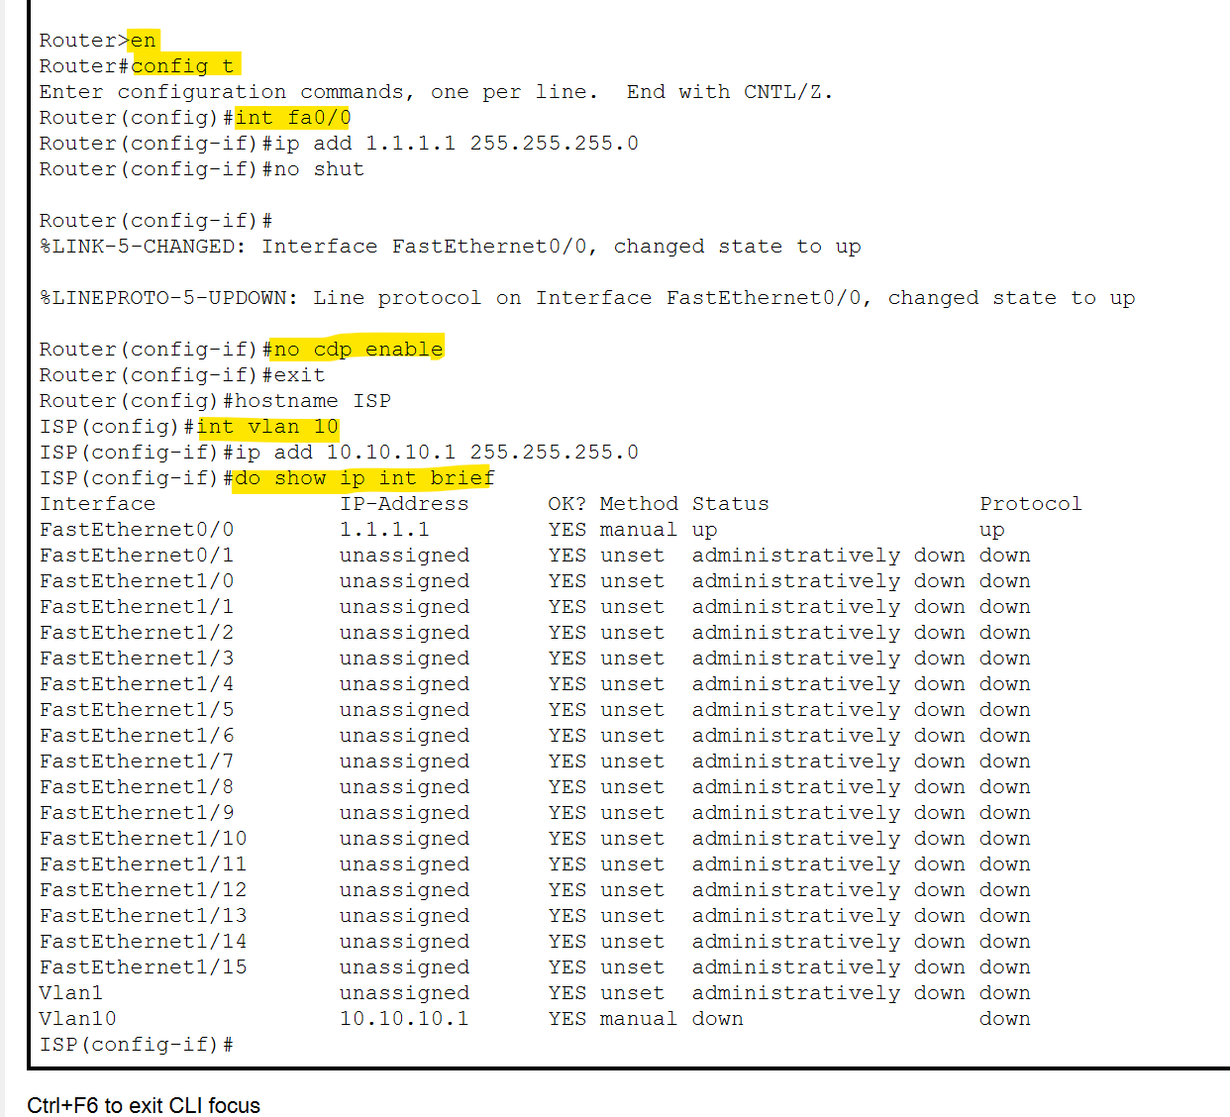

1. Now we will configure the switchport module

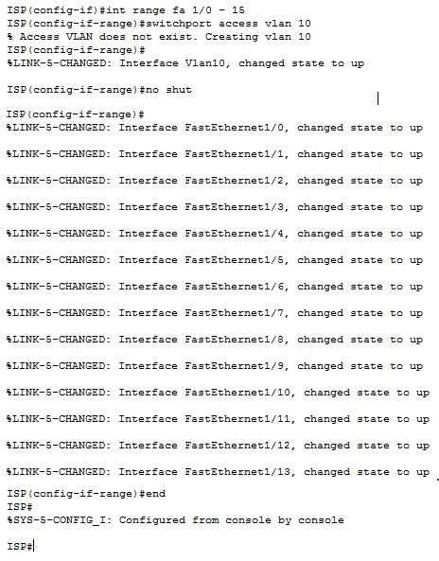

Now we have our VLAN and ports configured.



✓

1. Now we will connect our server to the ISP router. Connect (via straight through cable) from the fast ethernet port (fa0) on the server to a fast ethernet port (fa1/0) on the ISP router.

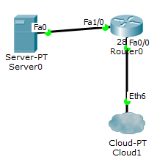

 ✓

1. We will now configure the server with the following IP settings

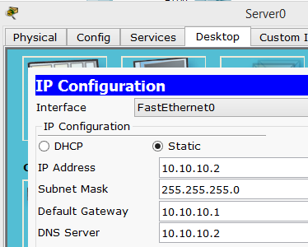



✓

Keep the server open, as we have a few more settings to complete

 ✓

1. Still in the server, go to the DNS and add in a record as shown which will be running off this server.

Make sure you turn on DNS

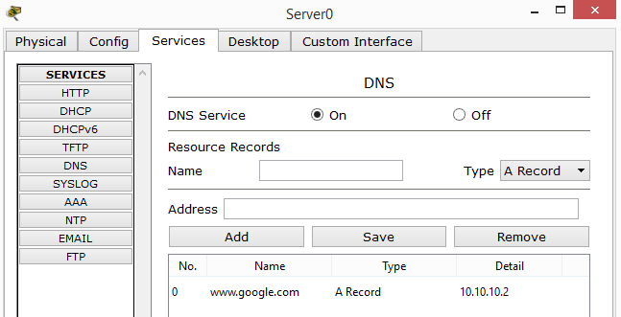

 ✓

1. Still in the server, go to HTTP and edit the welcome message to now read “Welcome to Google”

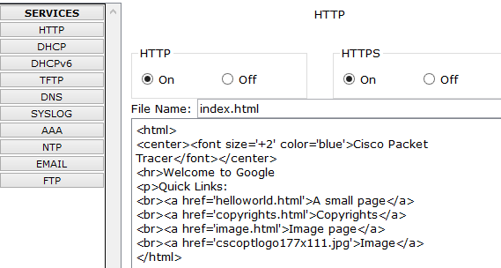

****That’s all the configuration on the server.

✓

1. Now we will setup DHCP on the ISP router.   
     
   When we connect in our DSL modems and connect in our users, they can pull DHCP from the ISP

****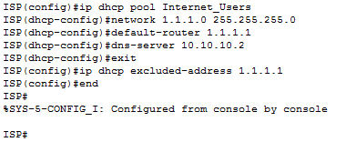

✓

1. Now under the WAN emulation tab, we add in 2 DSL modems, but we will only configure one side for the purpose of this lab. Once you complete this lab, you can setup the other side of our network.  
     
   Use the phone connection cable (it is to the right of the fiber cable) to connect the modem to the cloud (Port 0 phone on the modem → modem 4 port on the cloud and repeat for the other modem (this time to modem 5))

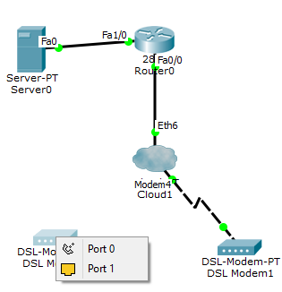

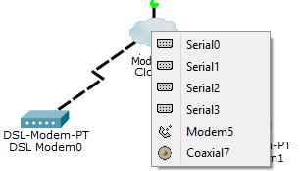



✓

1. Now we have our phone connection

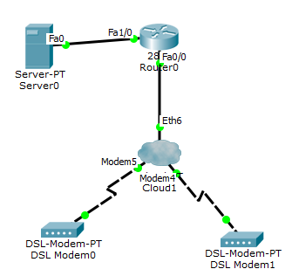

 ✓

1. We will add our home router which will connect to the DSL modem (straight through cable from fast ethernet on router to fast ethernet on the DSL modem).

****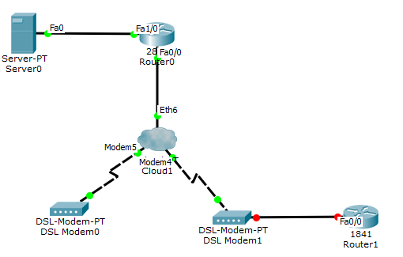

✓

1. Go into the home router and add a switch port module (users will connect to here) onto the router.

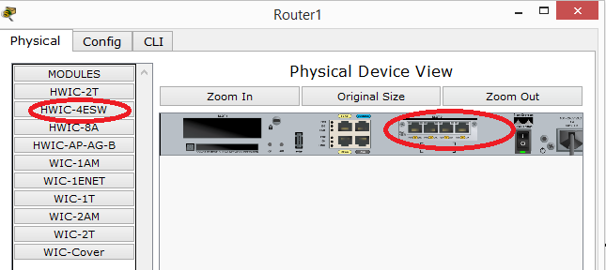



✓

1. Connect a user to the router (straight through cable) via FA0/0/0

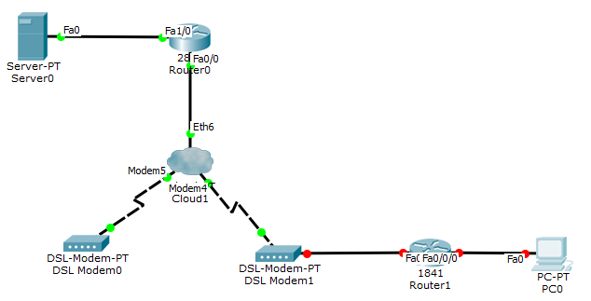

 ✓

1. We will now configure the connection between the home router and the modem

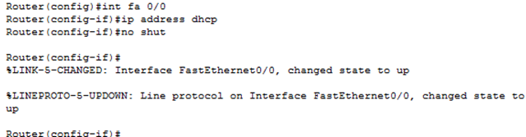

Now the connection between the router and modem will be green (if not, then troubleshoot)

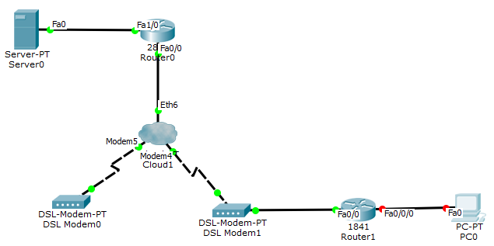



✓

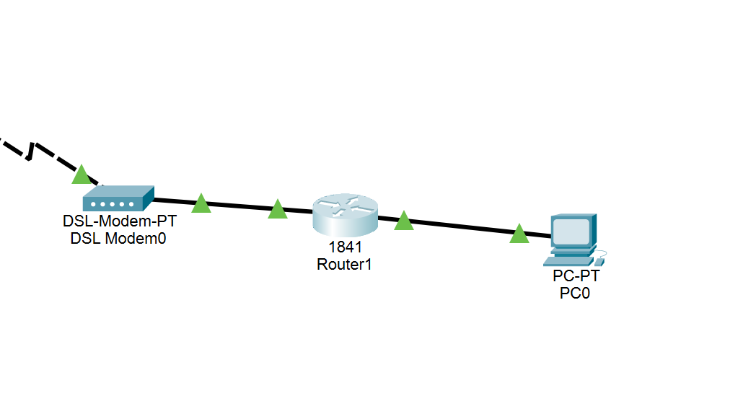

1. On the home router we will create the VLAN for our home users (we will start by renaming our router to Home_Router)  
     
   Connection should go green after we enter these commands - if not, then troubleshoot

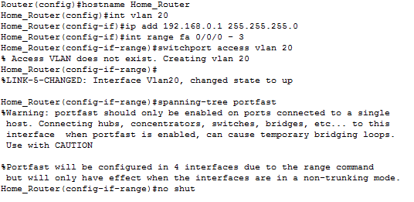

****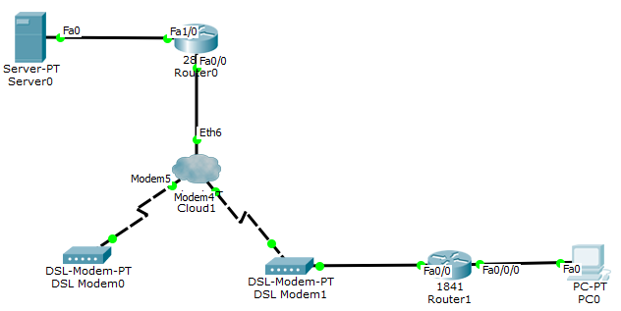

✓

1. Now we will crate a DHCP pool on the router.

****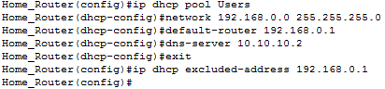

✓

1. No go to the user and use DHCP for IP configuration.

****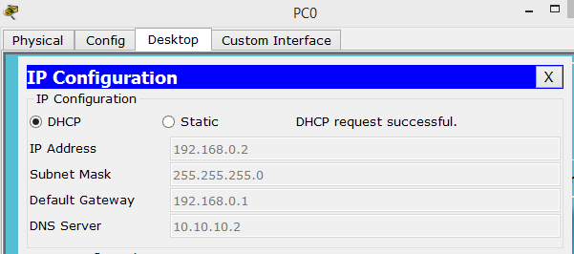

✓

1. We will now check our PC configuration and ping our VLAN our default gateway (192.168.0.1)

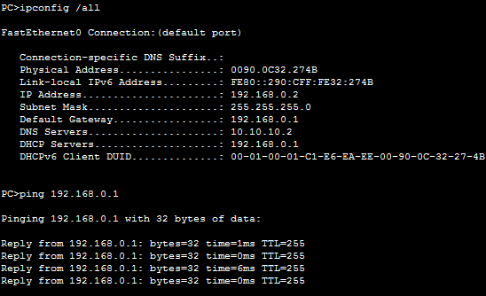



✓

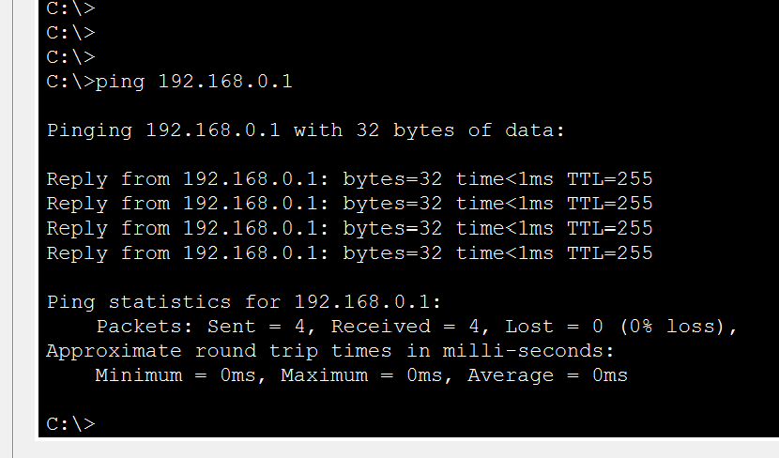

1. From the same PC, we will ping the DNS server (10.10.10.2)

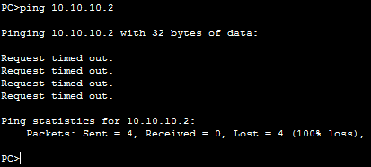

 ✓

1. This should **not** work as the ISP router does know what the address 192.168.0.1 is (it has never seen the 192.168’s before)

On our home router, we will create an access list that will find the VLAN 20 that we created.



✓

1. Now we created an ACL that matches our VLAN users.

Now we need to create a NAT pool to take our inside address (our 192 addresses) and map them to outside address (which our ISP assigned us).



We are mapping our inside addresses to the fa 0/0 interface which is 1.1.1.1 (assigned by the ISP)



✓

1. Now we need to tell the router what an inside and outside interface is   
     
   We will end with show NAT translations which there will be none (no packets have been sent)

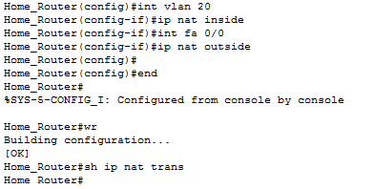

 ✓

1. Now let’s try another ping from the PC to the DNS server 10.10.10.2 and this time it should work

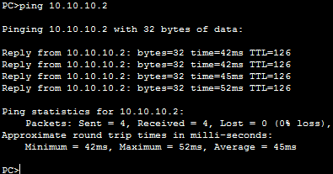



✓

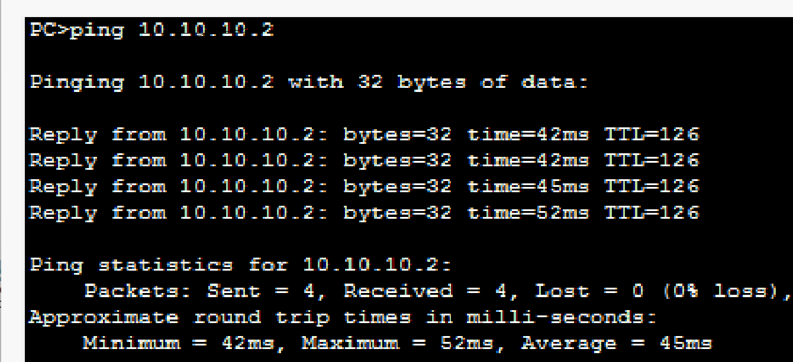

1. Now let’s go back and reap the show nat translation and we should get a different result (last time we go no results)

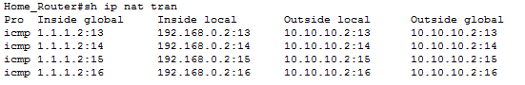

 ✓

1. Since NAT is working, you should now be able to get out to the Internet www.google.com

****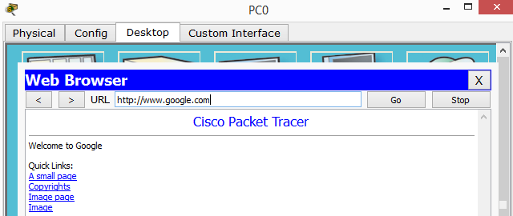

✓

You can do the same thing with another group of users connecting to the other modem (as we outlined in step 13). …..do you manage to get a connection to the Internet from this user? **YES.**

 ✓